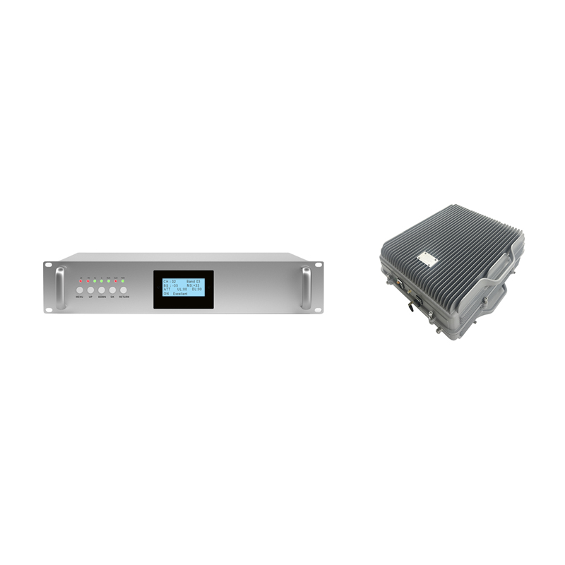
UHF380-470MHz Active DAS System
Model: AT-OPT-UHF380

Product Features:
- Support multi-band system.
- Optical transmission up to 10km (max.).
- Support OMS Lite local/remote control.
- Low noise and high reliability.
- Each master unit can support max.16 remote units.
- Support to monitor donor signal parameters for easy optimization and troubleshooting.

Application Scenario:


Technical Specifications:
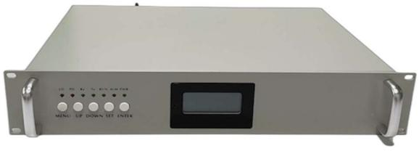

Specifications
Part Number | AT-OPT-UHF380MU-AIR
Duplex Frequency Range | 380-470MHz
Operational Bandwidth | 0.2-5MHz
Maximum Gain (UL/DL) | 40/40+3 dB
Pass Band Ripple | < +2dB
Optical Output Power | -6dBm+2dB @1550nm
Optical Receiver Sensitivity | > -15dBm
Uplink Output Power | 23dBm + 2dB
Manual Gain Control | 0 - 31dB @1dB step
Auto Level Control | > 20dB
Group Delay Time | < 1.5μs
VSWR | < 1.5
Noise Figure | < 6dB (uplink, with 1RU)
Spurious Emissions | Comply with 3GPP TS36.106
IMD3 | > 45dBc
Connector | 1*N-female, 8*LC/UPC duplex
Power Consumption | < 40W
Power Supply | AC100-240V, comply with IEC62368-1
Local Control | LCD+Keypad, WiFi, RJ45
OMC (Optional) | LTE Modem
Approx. Weigh | 10kg
Operating Temperature | -10 to + 55°C
Applications | Indoor (IP40)
Humidity | 5% to 95%
MTBF | > 50,000 hours
Installation | Rack mount
Dimension | Standard 2U (19” rack)
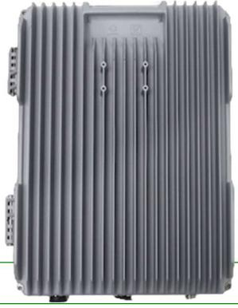

Specifications
Part Number | AT-OPT-UHF380RU-AIR
Duplex Frequency Range | 380-470MHz
Operational Bandwidth | 0.2-5MHz
Maximum Gain (UL/DL) | 45/40+3 dB
Auto Gain Control Range | 31dB
Pass Band Ripple | < +2dB
Optical Output Power | 3dBm+2dB @1310nm
Optical Receiver Sensitivity | > -15dBm
Uplink Output Power | 33dBm + 2dB
Auto Gain Control | 0 - 31dB @1dB step
Auto Level Control | > 20dB
Group Delay Time | < 1μs
VSWR | <1.5
Spurious Emissions | Comply with 3GPP TS36.106
IMD3 (2X37dBm) | < 45dBc
Connector | 1*N-female, 1*LC/UPC
Power Consumption | < 50W
Power Supply | AC100-240V, comply with IEC62368-1
Local Control | LCD+ Keypad, WiFi or RJ45
OMC (Optional) | Through MU via fiber
Approx. Weigh | 10kg
Operating Temperature | -10 to + 55°C
Applications | Indoor& outdoor (IP65)
Humidity | 5% to 95%
MTBF | > 50,000 hours
Installation | Wall mount
Dimension (without connector) | 385mm*307mm*204mm

Technical specification is subject to change without prior notice.

